June 7, 2015

Dr. Gao, BUPT

Hongfu Campus

**LABORATORY REPORT**

**DIGITAL CIRCUIT DESIGN**

**BINARY ADDER CIRCUITS**

**INTRODUCTORY SUMMARY**

Last week you sent me an introduction of this lab and asked me to finish the report before this Monday. Having analyzed the samples in our lab, I find this lab is about building a full adder.

As you know, this lab session builds on the work done in the pervious lab. From it, I learn how to construct more complex circuits by implementing three binary adder circuits (i.e., half and full adders).

**LAB MATERIALS**

For these experiments, I require the following TTL integrated circuits:

1. 7408 (labeled HD74LS08P) quadruple 2-input AND gates
2. 7400 (labeled HD74LS00P) quadruple 2-input NAND gates
3. 7432 (labeled HD74LS32P) quadruple 2-input OR gates

**LAB PROCEDURE**

To realize full adder, I should first build a half adder, so this experiment consists of two steps:

**Step 1 Half Adder**

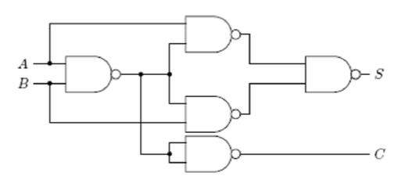

**Figure 1**- Half Adder: NAND implementation

First I designed and built an alternative Half Adder using 7408 and 7432 ICs (i.e., AND and OR gates, respectively), and inverters constructed from 7400 (i.e., NAND) gates. Then, I verified its functionality. Finally, I checked its operation against the Truth Table and found that this circuit can truly simulate a half adder.

**Step 2 Full Adder**

The Half Adder is so-called this because it cannot accept a “carry-in” input from a previous stage. The Half Adder is quite satisfactory for adding 1-bit numbers or for the LSD (least significant digit) stage of an Adder for multiple bit numbers. However, in order to construct multiple bit Adders, I need to extend the Half Adder to accept a carry input for all digits beyond the LSD.

A Full Adder in block form is shown in Figure 2. It can be built from two Half Adders. I verified its functionality by checking the operation against Truth Table of full adder.

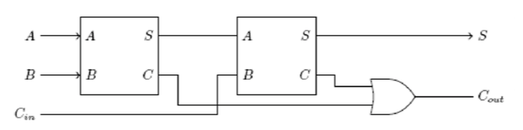

**Figure 2** Full Adder built from 2 Half Adders: Circuit diagram

**CONCLUSION**

By doing this experiment by myself I gradually know about how to simulate a complex circuit using kinds of gates to realize a specific function. In this lab I learned a lot about how to build a circuit and how to use a multimeter.

Sincerely,

Zhu Siyang